

**QE**

**The story so far**

Andrew G Haldane

Dean’s Lecture

Cass Business School Wednesday 19 October 2016

# The Rise of QE

## Bloomberg news stories containing “QE” or “Quantitative Easing”

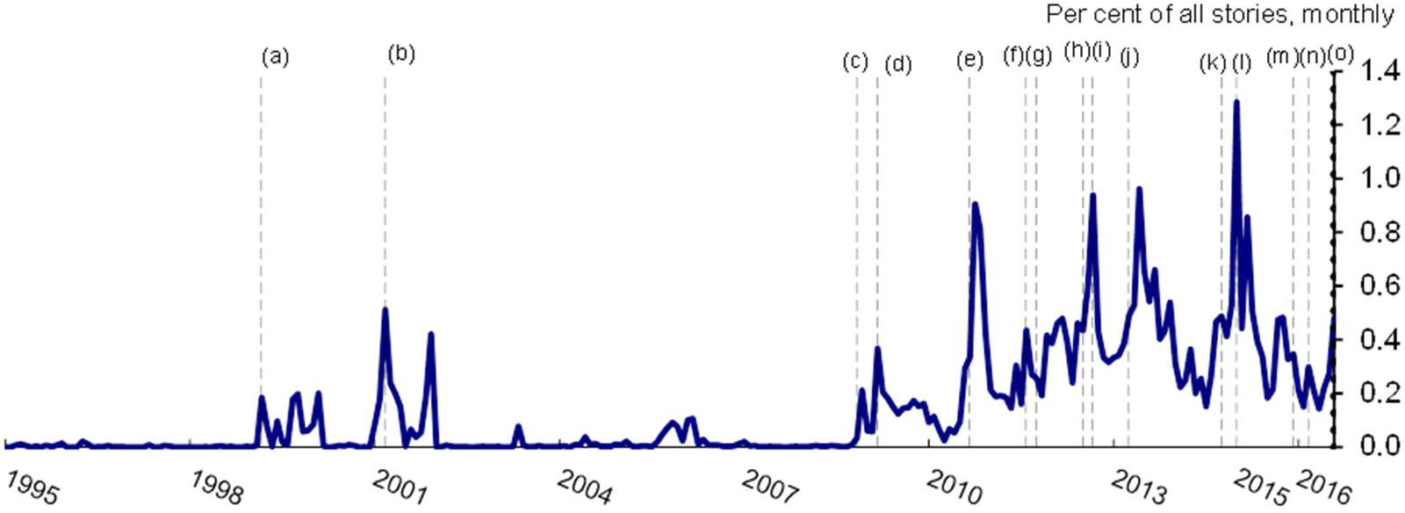

Monthly count of stories containing “QE” or “Quantitative Easing” as a percentage of all stories.

(a) Minutes of BoJ meeting show one member voting for “quantitative easing”; (b) BoJ announces QE; (c) Fed announces QE1; (d) BoE announces QE1; (e) Fed announces QE2; (f) Fed announces Maturity Extension Program; (g) BoE announces QE2; (h) BoE announces QE3; (i) Fed announces QE3; (j) BoJ announces QQE; (k) BoJ announces QQE2; (l) ECB announces QE; (m) ECB announces extension to QE; (n) ECB announces expansion of QE; (o) BoE announces QE expansion in the aftermath of the UK referendum vote to leave the EU.

Sources: Bloomberg and Bank calculations.

2



**Overview**

* History of Central Bank Balance Sheets
* Recent QE
* Channels of QE
* Impact of QE
* State-dependency and Spillovers from QE



**History of QE**

**Bank of England Balance Sheet – % of GDP (1700-2014)**

War of Spanish Succession

Bullion, coin and retained notes Other securities including repos Government securities

Wall Street

per cent of nominal GDP

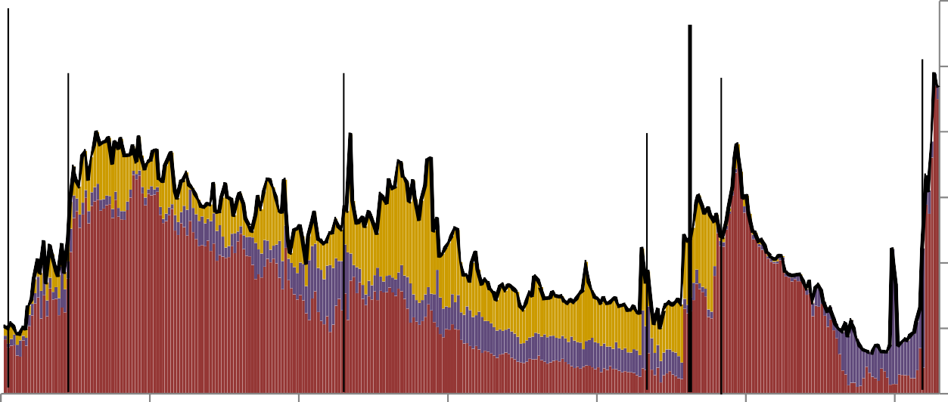30

South Sea Bubble

including loan to APF

Hundred

Days War

Crash

WWII

WWI

Financial

Crisis 25

20

15

10

5

0

1700 1750 1800 1850 1900 1950 2000

Source: Hills, Thomas and Dimsdale (2015).

# Bank of England Balance Sheet – % of Government Debt (1700 – 2014)

##### War of Spanish

Bullion, coin and retained notes Other securities including repos Government securities

per cent of nominal government debt

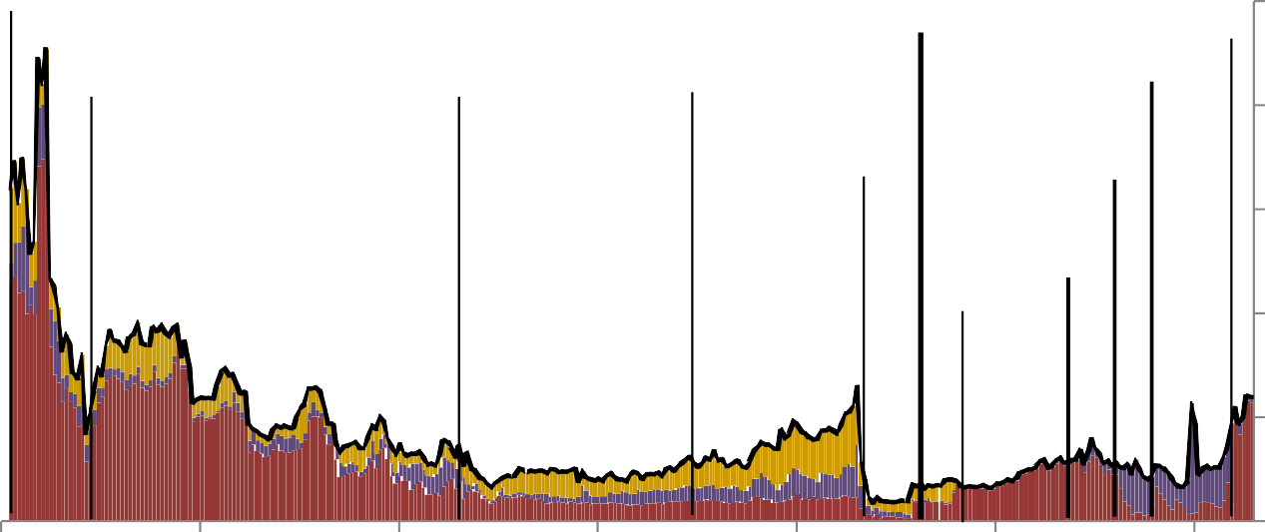Succession

South Sea Bubble

Hundred Days War

Long Depression

Wall Street Crash

WWI

Financial Crisis 1990s recession

1980s

including loan to APF

recession 1970s

recession

100

##### 80

60

WWII

40

20

0

1700 1750 1800 1850 1900 1950 2000

Source: Hills, Thomas and Dimsdale (2015).

# Central Bank Balance Sheets (1900-2013)

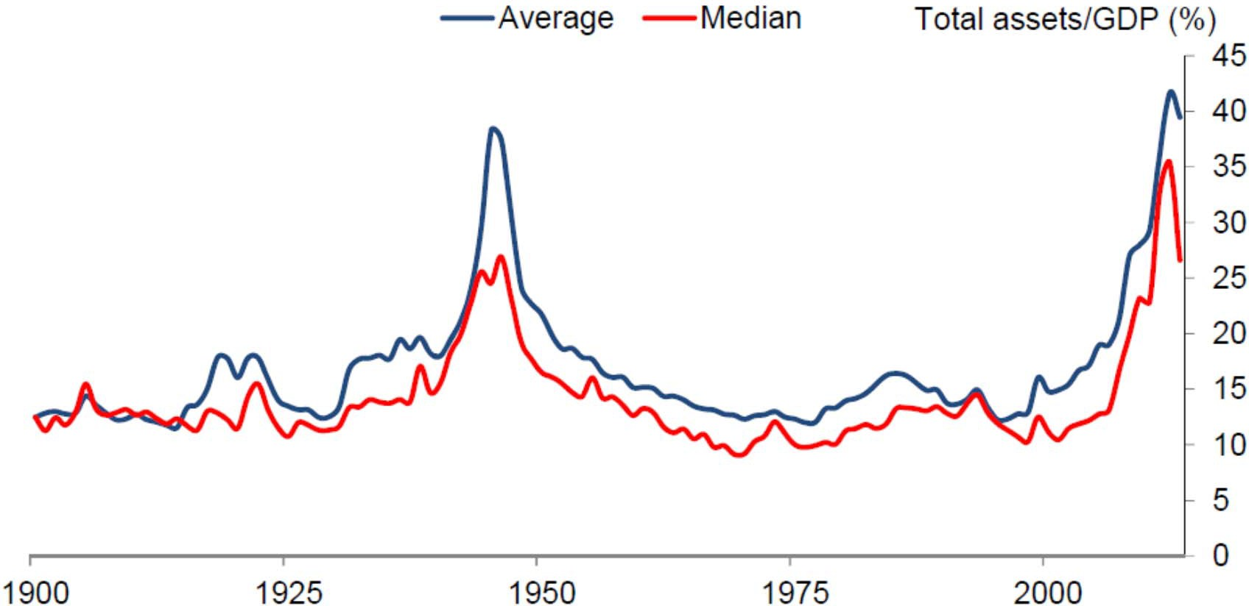

Countries covered are: Australia, Canada, Finland, France, Germany, Italy, Japan, Norway, Sweden, Switzerland, the United Kingdom and the United States.

After 1999, they consider aggregated balance sheet data for the European System of Central Banks (ESCB) in lieu of the euro area countries Finland, France, Germany and Italy. Source: Ferguson, Schaab and Schularick (2015). ‘Central bank balance sheets: expansion and reduction since 1900’.



# Recent QE

8

**QE Timeline**

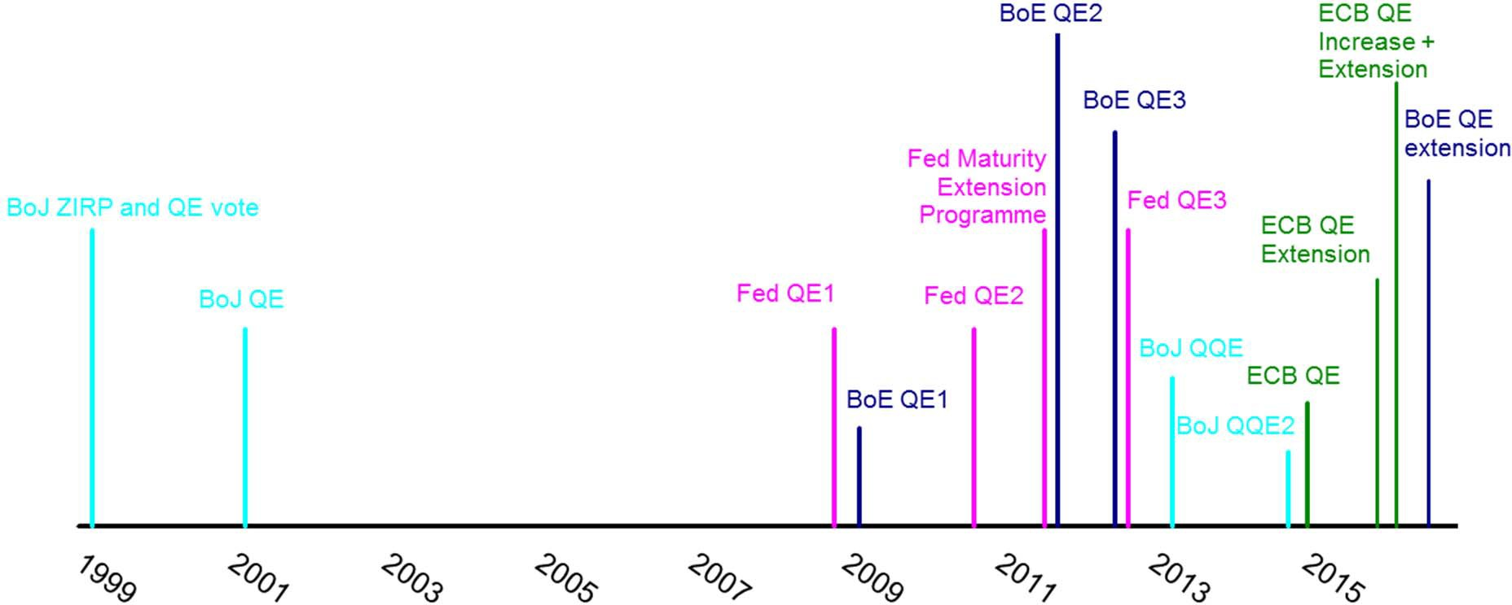

**Central bank balance sheets**

2006 2008 2010 2012 2014 2016 2018

of GDP 130%

120%

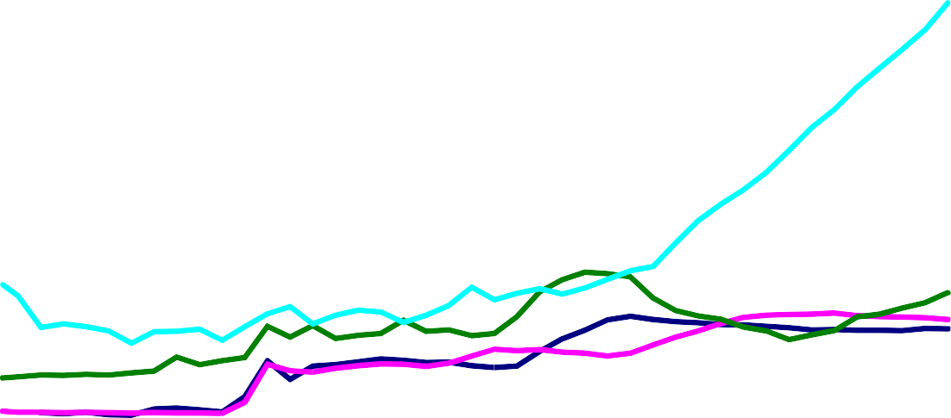

Bank of England

Per cent

Federal Reserve

ECB Forecast

Bank of Japan

110%

100%

90%

80%

70%

60%

50%

40%

30%

20%

10%

0%

Source: Bank of England, Federal Reserve, Bank of Japan, European Central Bank Bloomberg, Thomson Reuters Datastream and Bank calculations.

# Central bank balance sheets

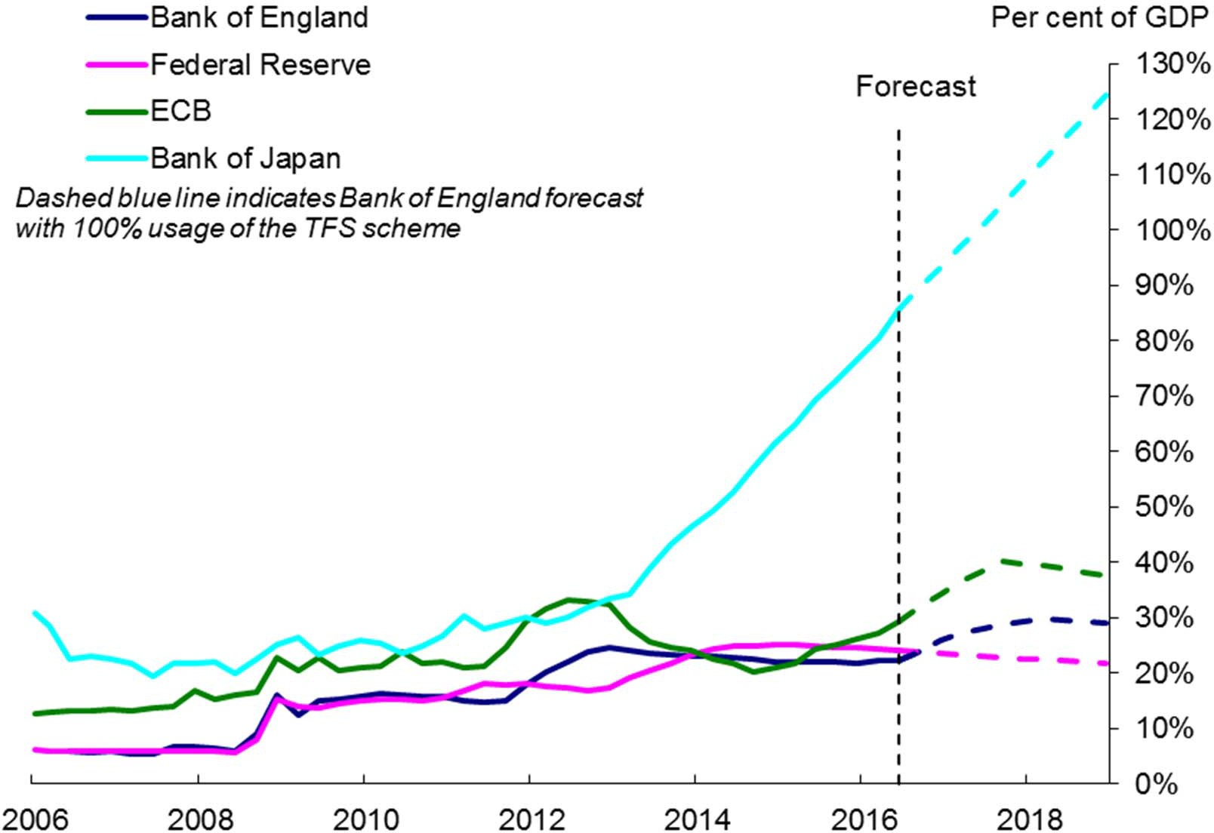

Source: Bank of England, Federal Reserve, Bank of Japan, European Central Bank Bloomberg, Thomson Reuters Datastream and Bank calculations.

# Central bank balance sheets

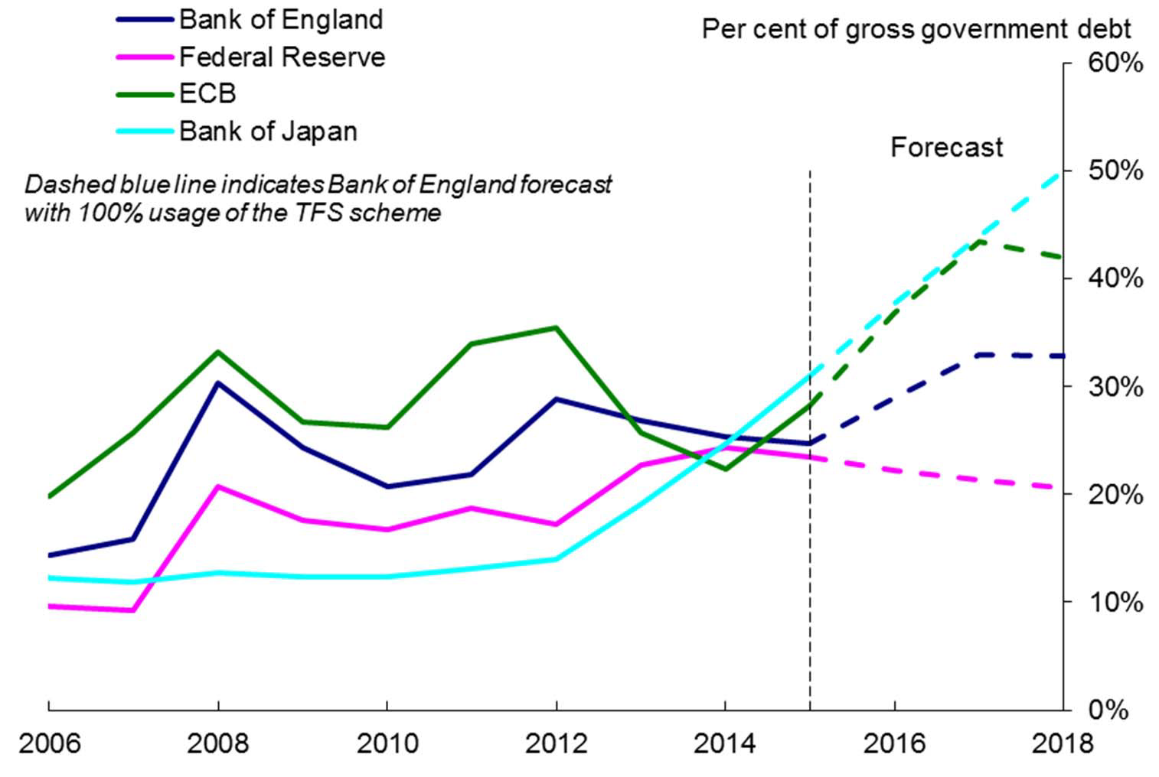

Source: Bank of England, OBR, IMF WEO, OECD, Global Financial Data, Federal Reserve Board, Federal Reserve Bank of St. Louis, Bank of Japan, European Central Bank Bloomberg, Thomson Reuters Datastream and Bank calculations.

# Types of Asset Purchases

*Credit risk*

**Corporate bonds**

**Covered bonds/ABS**

**Agency MBS**

**Equities**

**Real estate derivatives**

**Central bank reserves**

**Government bonds**

*Duration risk*

**Early 2000s - QEJ**

*Credit risk*

**Corporate bonds**

**Covered bonds/ABS**

**Agency MBS**

**Equities**

**Real estate derivatives**

**Central bank reserves**

**GovernmBeonJt bonds**

*Duration risk*

**2008-2010 - QE 1,2,3**

*Credit risk*

**Corporate bonds**

**Covered bonds/ABS**

**Agency MFeBdS**

**Equities**

**Real estate derivatives**

**Central bank reserves**

**GoveFrnemd,eBnot Ebonds**

*Duration risk*

**2011-2012 - LTROs**

*Credit risk*

**Corporate bonds**

**Covered ECB**

**bonds/ABS**

**Agency Fed MBS**

**Equities**

**Real estate derivatives**

**Central bank reserves**

**GoFveedr,nBmoeEn,tEbCoBnds**

*Duration risk*

*Credit risk*

**2013-2014 – QQE 1,2**

**EqBuoitJies**

**Corporate**

**bonds**

**Covered ECB**

**bonds/ABS**

**Agency MBS**

**Real estate deriBvoatJives**

**Central bank reserves**

**GovernmeBnotJbonds**

*Duration risk*

**2015 – ECB QE**

*Credit risk*

**Corporate bonds**

**Covered ECB**

**bonds/ABS**

**Agency MBS**

**EqBuoitJies**

**Real estate deriBvoatJives**

**Central bank reserves**

**GovernmECenBt, bBoonJds**

*Duration risk*

**2016 – ECB QE, BoE QE, BoJ**

*Credit risk*

**Corporate ECB, BoE**

**bonds**

**Covered bonds/ABS**

**Agency MBS**

**EquBitioeJs**

**Real estate BoJ derivatives**

**Central bank reserves**

**GoveErnCmBe, nBtobEo, nBdosJ**

*Duration risk*



**Channels of QE**

20

**How does QE work?**

*“The problem with QE is that it works in practice, but it doesn’t work in theory.”*

– Ben Bernanke, January 2014

**What do you need to believe for QE to work?**

* **Information frictions**
  + QE signals lower future interest rates – signalling channel
  + QE lowers uncertainty – uncertainty channel
  + QE lowers exchange rate – exchange rate channel
* **Financial frictons**
  + QE lowers liquidity premia – liquidity channel
  + QE causes a portfolio switch into higher risk assets – portfolio balance channel
  + QE encourages new borrowing/lending – lending channel

**Transmission mechanism of QE**

#### 5. Confidence

5. Risk aversion/ uncertainty

2. Portfolio rebalancing:

Asset Purchases

* + - Duration
    - Local supply

1. Exchange rate

1. Policy signalling

Relative asset prices

Total wealth

Spending and income

Inflation and growth

3. Liquidity

Cost of borrowing

Money

6. Bank lending

**Channels of QE - what do you have to believe?**

|  |  |  |
| --- | --- | --- |
| **Channel** | **What do you have to believe for this channel to work? (what frictions?)** | **State contingent?** |
| 1. Policy signalling | Information frictions - need to “put money where your mouth is”. | Yes |
| 2. Portfolio balance   * Duration * Local supply | Preferred-habitat demand – preferences for bonds of specific maturities. Limits to arbitrage. Some investors do not view bonds of different maturities as perfect substitutes. | Yes |
| 3. Market liquidity premia | Markets dysfunctional. Transaction costs. | Yes |
| 4. Exchange Rate | Exchange rate a function of interest rate differentials and/or risk premia | Yes |
| 5. Confidence/risk aversion/uncertainty | QE improves the economic outlook/reduces risk of bad outcomes (via any mechanism) | Yes |
| 6. Bank lending | Increased deposits expand banks’ balance sheets. Bank lending is not constrained. Agents cannot perfectly substitute other forms of lending. | Yes |



**Impact of QE**

25

**Transmission mechanism of QE**

5. Confidence

5. Risk aversion/ uncertainty

2. Portfolio rebalancing:

Asset Purchases

* + Duration
  + Local supply

4. Exchange rate

1. Policy signalling

Relative asset prices

Total wealth

Spending and income

Inflation and growth

3. Liquidity

Cost of borrowing

Money

6. Bank lending

26

27

**Lots of evidence for asset price impact**

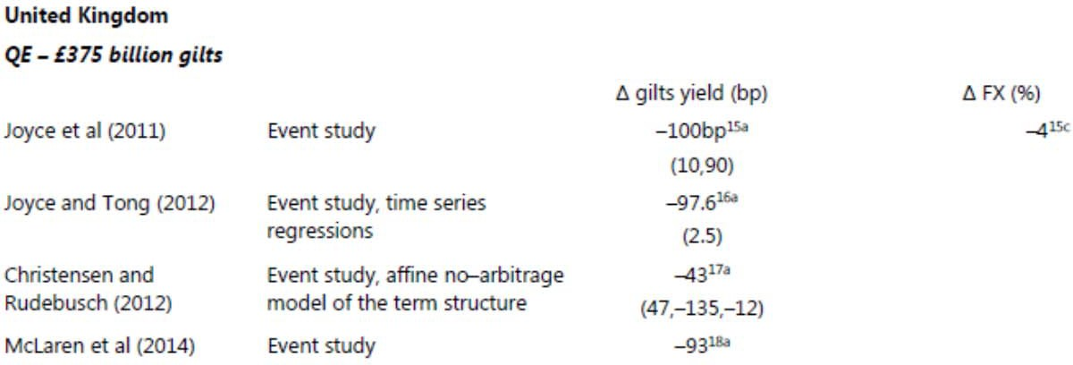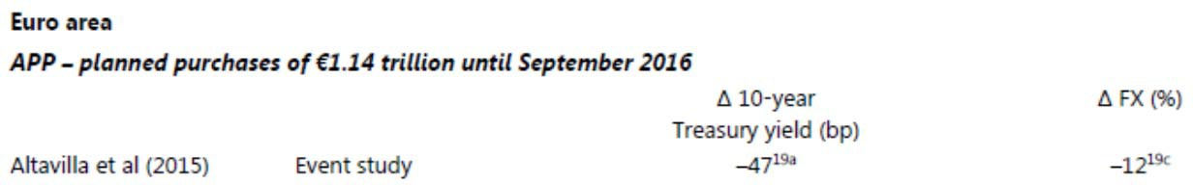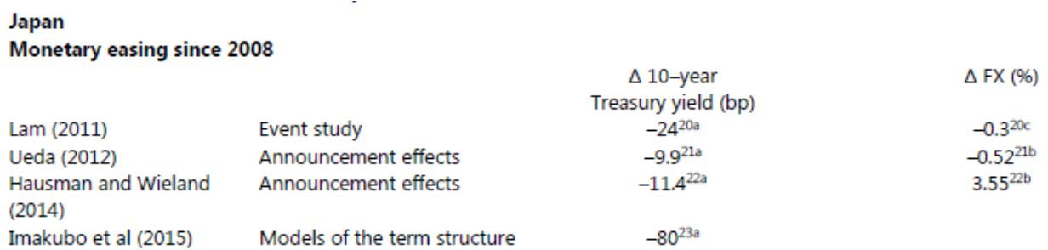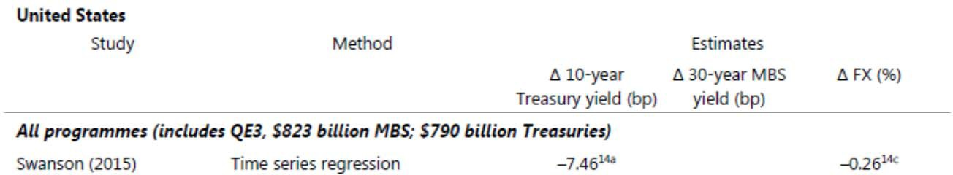

‘Unconventional Monetary Policy: a re-appraisal’, Claudio Borio and Anna Zabai



**Portfolio rebalancing/liquidity channel**

**Change in long rates around selected QE announcements**

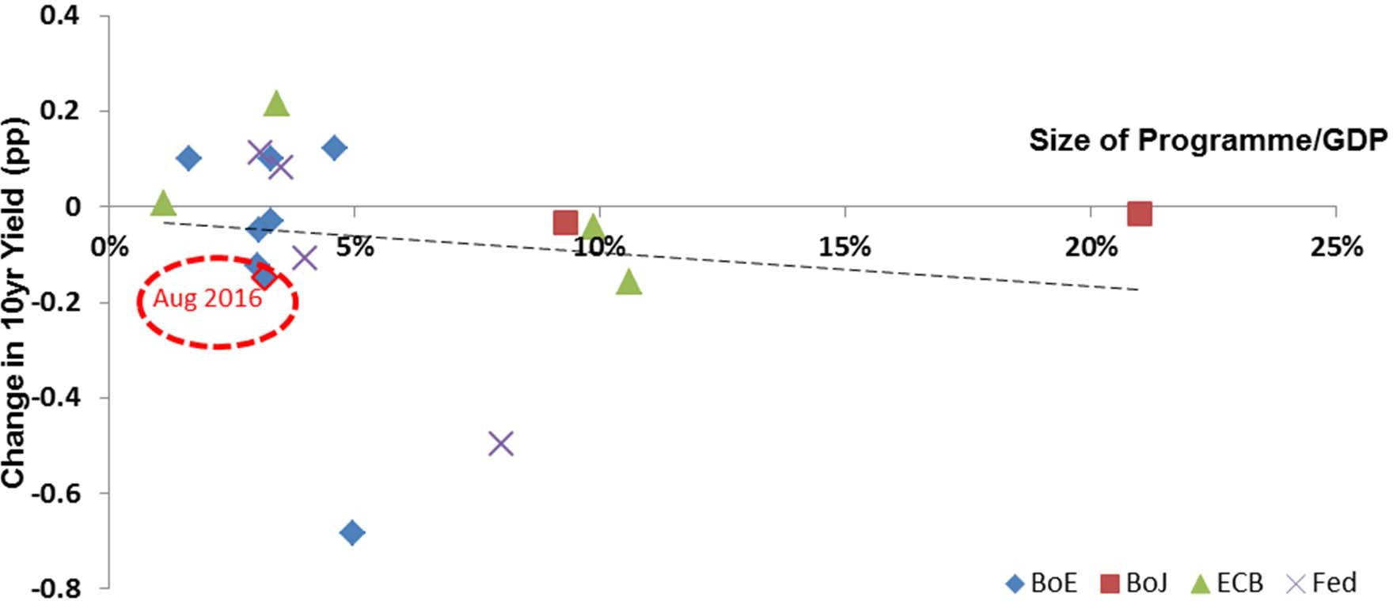

Change in 10 year spot market interest rates over two day windows around QE events, against size of announcement relative to that economy’s GDP at the time.

Note: does not control for expectations of QE announcements. Source: Bloomberg and Bank calculations.

**Policy signalling channel**

**Change in short rates around selected QE announcements**

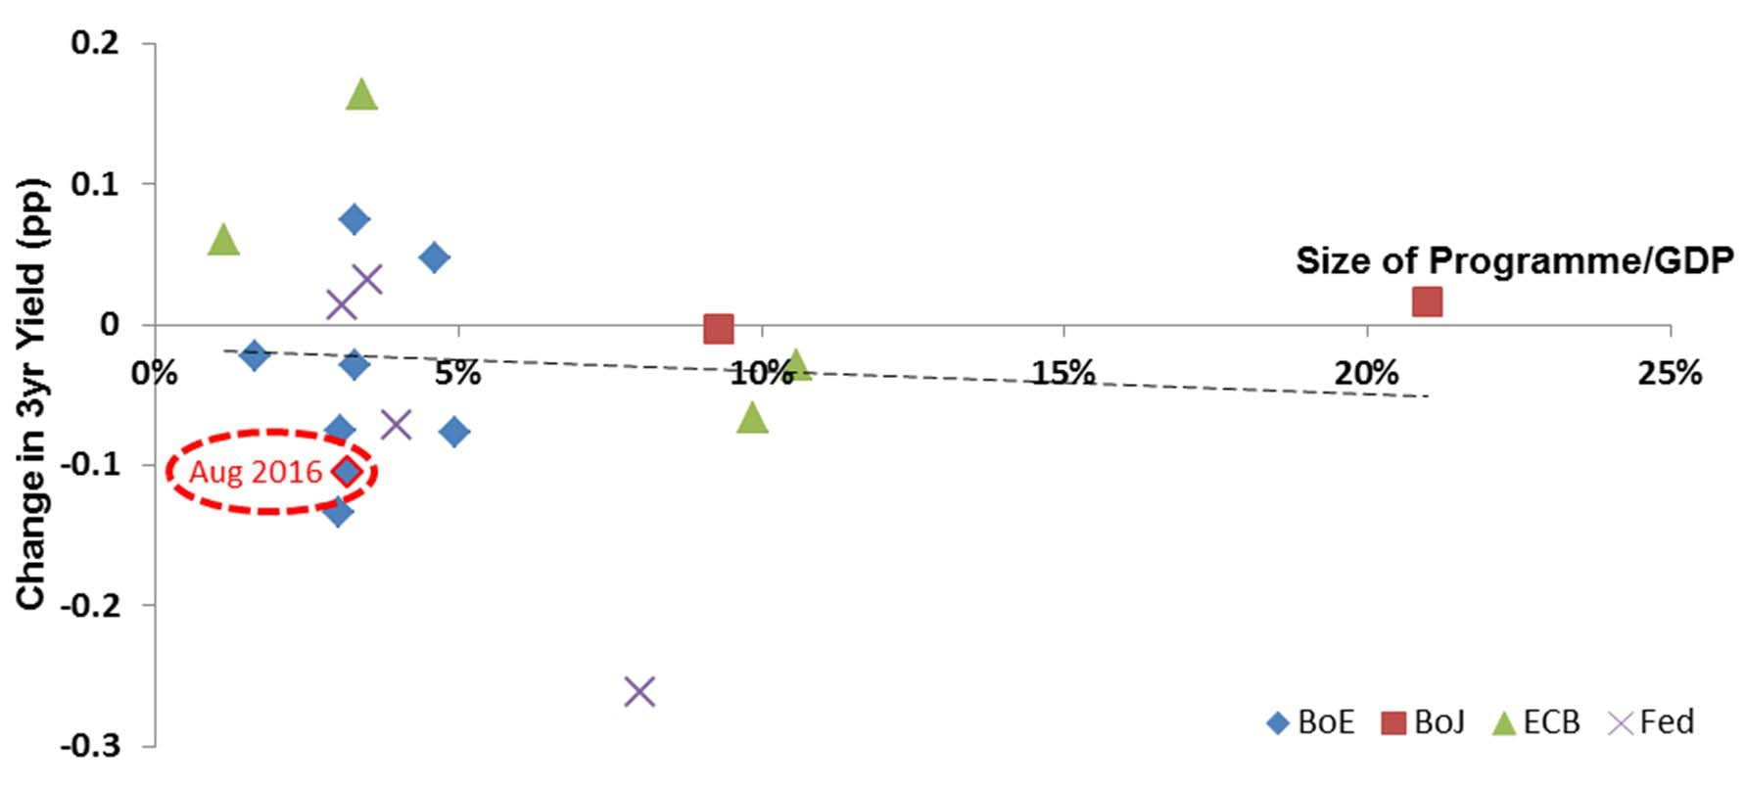

Change in 3 year spot market interest rates over two day windows around QE events, against size of announcement relative to that economy’s GDP at the time.

Note: does not control for expectations of QE announcements. Source: Bloomberg and Bank calculations.

**Confidence/uncertainty channel**

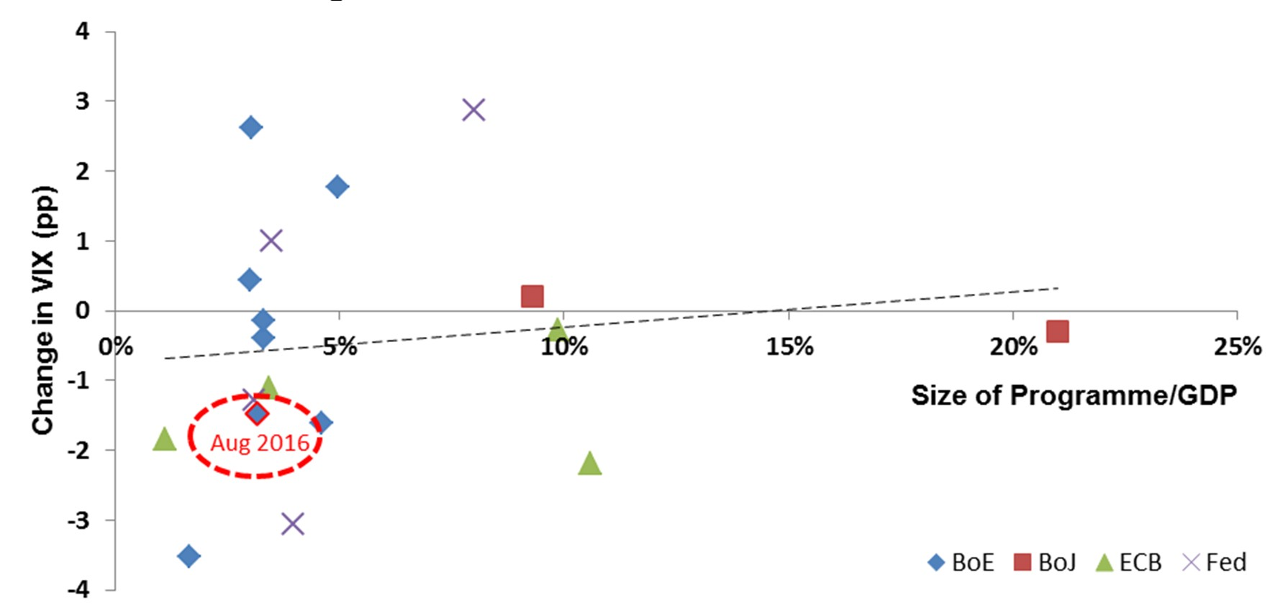**Change in VIX around selected QE announcements**

Change in VIX over two day windows around QE events, against size of announcement relative to that economy’s GDP at the time. Note: does not control for expectations of QE announcements.

Source: Bloomberg and Bank calculations.

**Exchange rate channel**

**Change in effective exchange rates around selected QE announcements**

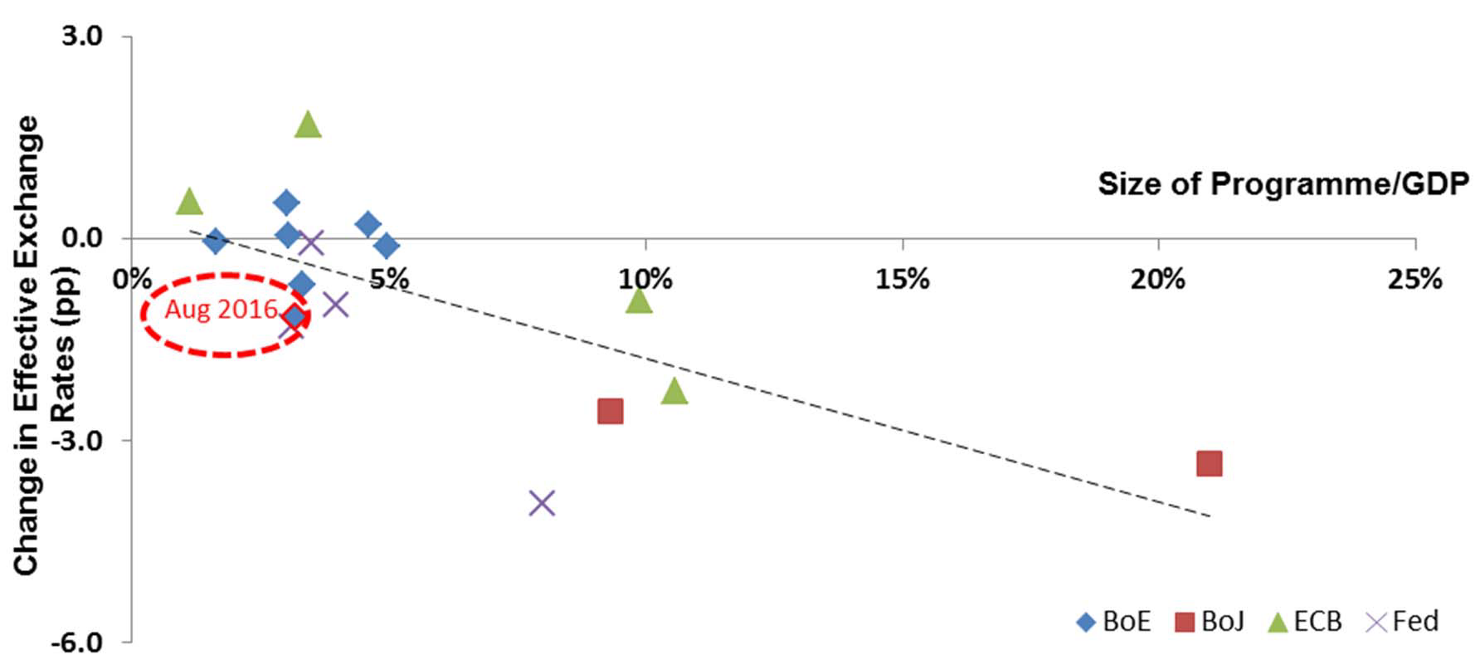

Change in effective exchange rates over two day windows around QE events, against size of announcement relative to that economy’s GDP at the time. Note: does not control for expectations of QE announcements.

Source: Bank of England, BIS, ECB, Federal Reserve, Bank calculations.

**Portfolio balancing channel**

**Change in corporate bond yields around selected QE announcements**

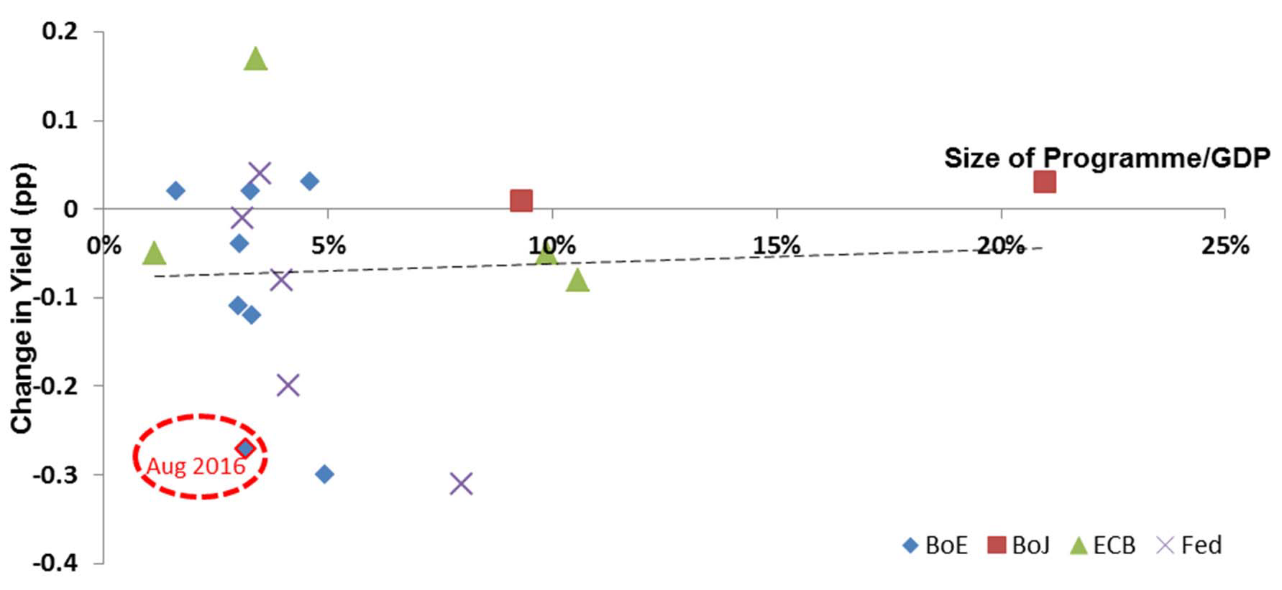

Change in investment grade corporate bond yields over two day windows around QE events, against size of announcement relative to that economy’s GDP at the time.

Note: does not control for expectations of QE announcements. Source: BoA Merrill Lynch and Bank calculations.

**Portfolio balancing channel**

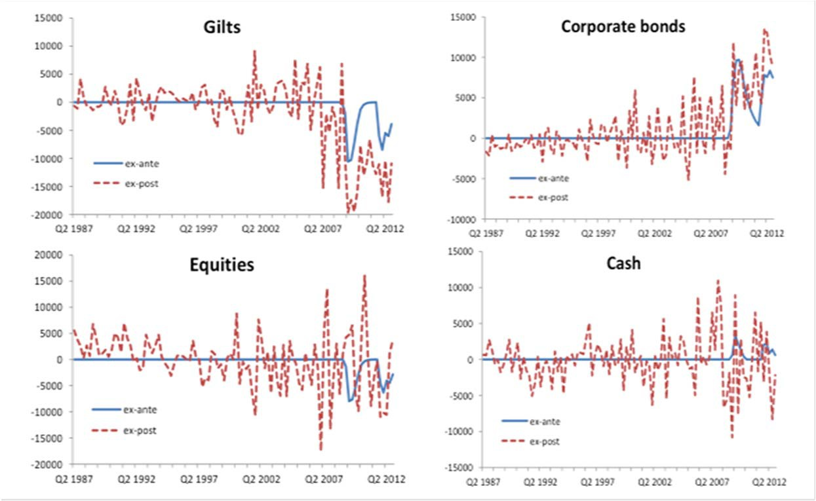**Impact of QE on UK insurance companies and pension funds, ex-ante and ex-post QE effects, £ million**

Source: Joyce, Liu and Tonks (2015)

**Sterling corporate bond issuance has been strong since QE**

**Cumulative gross issuance of bonds by UK, US and EA19 PNFCs**

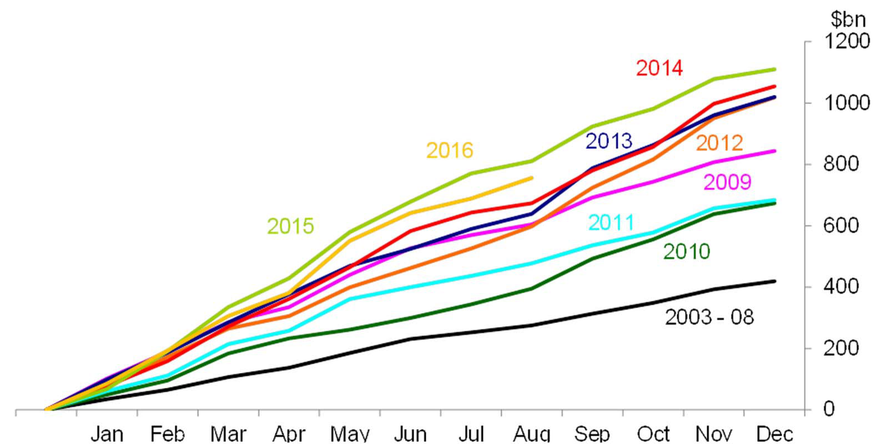

Source: Dealogic and Bank calculations

1. Issuance by UK, US and EA19 private non-financial corporations (PNFCs) or their financial vehicles. Includes investment grade and non-investment grade bonds. Data are subject to revisions. 2003-08 is an average over the period.

**Bank lending channel**

**Bank lending to the real economy**

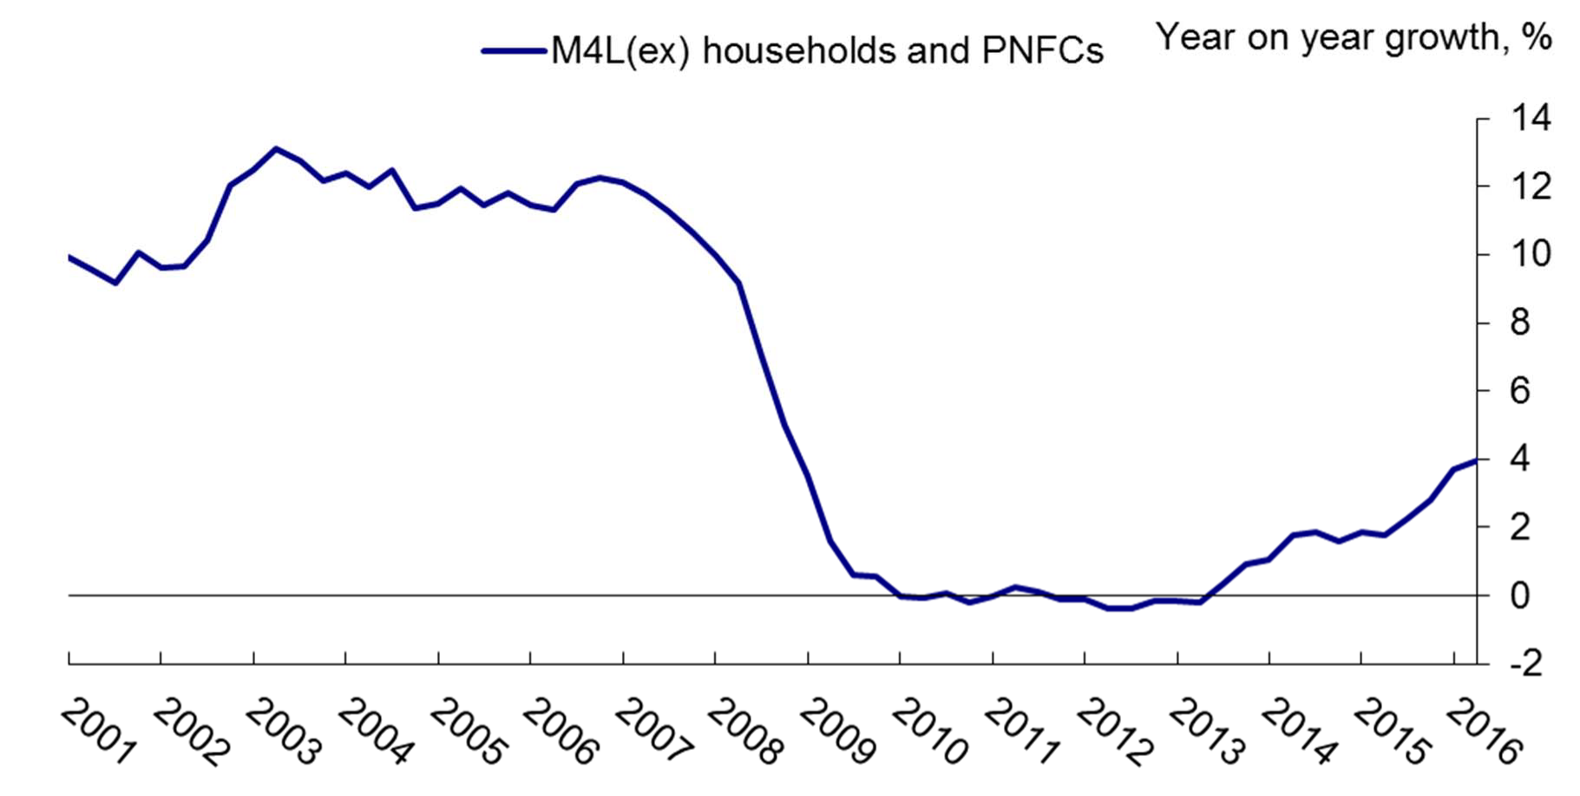

**Case Study:**



**The Bank Of England’s August 2016 Monetary Policy Package**

36

**The Package of Monetary Policy Measures**

* + Announced by the Bank of England’s MPC on 4 August 2016
  + The package comprised:

1. Rate cut:
   * 25bp cut in Bank Rate to 0.25%;
2. Targeted funding:
   * A new Term Funding Scheme;
3. Asset purchases:
   * The purchase of up to £10bn of UK corporate bonds
   * An expansion of UK government bond purchases by

£60bn to £435bn

**Immediate Financial Market Reaction**

fall in bond yields

depreciation of sterling stock market rally

sharp tightening in corporate bond spreads

|  |  |  |
| --- | --- | --- |
|  | **1 day reaction**  **(3-4 August)** | **2 day reaction**  **(3-5 August)** |
| **UK 3-year forward overnight index swap rate** | -8bps | -5bps |
| **10-year gilt yield** | -17bps | -15bps |
| **£ ERI** | -1.3% | -1.4% |
| **FTSE All Share** | +1.5% | +2.4% |
| **Sterling IG**  **corporate bond spreads** | -10bps | -18bps |
| **Sterling HY**  **corporate bond spreads** | -8bps | -22bps |

**Elements of Surprise**

**Market profile for Bank Rate**

**before and after the August MPC announcement**

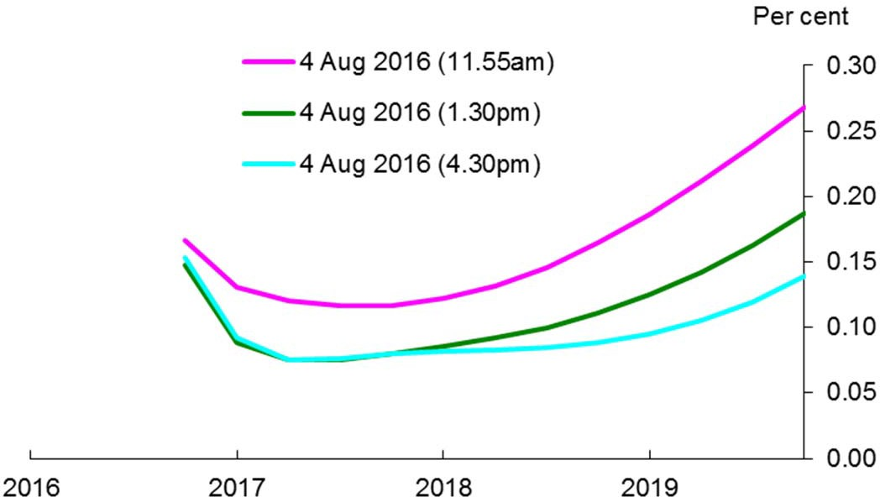

**A**

**B**

* [**A**]: little reaction at the very short end of UK yield curve
* [**B**] at longer horizons, large falls and curve flattening

**Elements of Surprise**

**Non-financial corporate investment grade spreads, June-September2016**

Sterling IG Dollar IG Euro IG Basis points

200

Referendum July MPC

Aug MPC

180

160

140

120

100

Jun 2016

Jul

80

Aug Sep

**Elements of Surprise**

**1-day change in sterling exchange rate index vs change in UK 2-year interest rates relative to US and German interest rates around UK monetary policy changes**

Rate Change

Rate Change & QE QE

1.5

1.0



%

∆Exchange Rates

% ∆ InterestRates

0.5

0.0

-0.25 -0.2 -0.15 -0.1 -0.05 0 0.05 0.1 0.15 0.2

-0.5

**August 4**

-1.0

-1.5

**Local Supply Effects**

**Change in gilt yields-to-maturity and OIS curve on 4 August 2016**

yields on sub 3y bonds fell less (ineligible for asset purchases)

3yrs 7yrs 15yrs

OIS

Percentage points

0.00

-0.02

> 3-year

Sub 3-year

yields on 3y+ bonds fell more (eligible for asset purchases)

-0.04

-0.06

-0.08

-0.10

-0.12

-0.14

-0.16

-0.18

-0.20

2016

2026

2036

2046

2056

2066

gilt yields fell more than swap yields: swaps not eligible

for asset purchases

**Transmission mechanism of QE**

5. Confidence

5. Risk aversion/ uncertainty

2. Portfolio rebalancing:

Asset Purchases

* + Duration
  + Local supply

1. Exchange rate

1. Policy signalling

Relative asset prices

Total wealth

Spending and income

Inflation and growth

3. Liquidity

Cost of borrowing

Money

6. Bank lending

**Evidence on Second Leg More Mixed**

|  |  |  |  |
| --- | --- | --- | --- |
| **Study** | **Episode** | **Real GDP** | **CPI** |
| **Baumeister and Benati (2013)** | UK/US QE1 | 1.8% / 1.08% | 1.5% \ 0.84% |
| **Kapetanios, Mumtaz, Stevens and Theodoris (2012)** | UK QE1 | 2.5% | 1.5% |
| **Weale and Wieladek (2015)** | UK/US QE1 | 2.52% / 0.72% | 4.2% / 0.76% |
| **Giannone, Lenza, Pill and Reichlin (2014)** | ECB Liquidity policy  2008/2009 | 2% in IP | N/A |
| **Altavilla, Giannone and Lenza (2014)** | ECB OMT Impact on  Spain/Italy | 2% / 1.5% | 0.74% / 1.21% |
| **Schenkelberg and Watzka (2013)** | Japan QE1 | 0.5% in IP | No impact |
| **Bank of Japan (2015)** | Japan QE2 | 1-3% | 0.6-1% |
| **Chen, Curdia and Ferrero (2012)** | US QE2 | 0.39% | 0.12% |
| **Del Negro, Eggertson, Ferrero and Kiyotaki (2015)** | Fed MBS + Liquidity policies | 5% | 3% |
| **Gertler and Karadi (2013)** | QE1 – MBS Purchases | 3.5% | 4% |
| **Gertler and Karadi (2013)** | QE1 – Sovereign Purchases | 2.2% | 3% |

Note: Studies in yellow are empirical VAR studies, while those in white provide multipliers from structural empirical models.

**Identifying QE’s Impact**

* Most studies feed “event study” asset price responses through a macro model
* What if asset price responses are persistent?

**Summary of asset price movements* around BoE QE 1**

**QE1: total of £200 billion purchases**



**Asset**

**Change around QE1 announcements (Feb 09, Mar 09, May 09,**

**Aug 09, Nov 09, Feb 10)**

**Change**

**4 March 2009 – 22 Jan 2010**

**Gilts (5-25 year average)** -104 -6

|  |  |  |
| --- | --- | --- |
| **Corporate yields (investment-grade)** | (o/w -90 gilt-OIS spread)  -70 | (o/w -41 gilt-OIS spread)  -387 |
| **Corporate yields (high-yield)** | -150 | -1944 |
| **FTSE All-Share** | -3% | +47% |
| **Sterling ERI** | -4% | +3% |





* In basis points, unless otherwise specified.

**Some New Estimates**

* + Estimated VAR for UK, US and Japan QE programmes
  + Four different identification schemes:
    - Based on ordering, sign and variance restrictions
  + Robustness check
  + In line with Weale and Wieladek

**Transmission of US QE (1% of nominal GDP)**

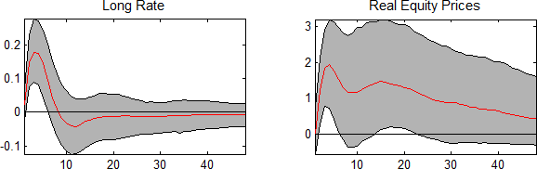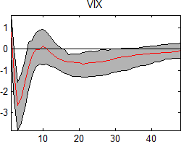

Note: Graph shows impulse responses to 1% surprise asset purchase announcement, identified with a Choleski decomposition. The unit on the x-axis is months. Gray error bands are 68% quantiles and the red lines show the median. Estimation period is March 2009 to February 2015.

See Haldane et al (2016). 47

**Impact of US QE (1% of nominal GDP)**

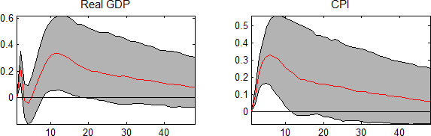

Note: Graph shows impulse responses to a 1% of nominal GDP surprise asset purchase announcement, identified with a Choleski decomposition. The unit on the x-axis is months. Estimation period is March 2009 to February 2015. The grey error bands are 68% quantiles and the red lines show the median. See appendix of Haldane et al (2016).



**Not all QE created equally**

**Peak impact of a central bank balance sheet expansion of 1% of nominal GDP**



|  |  |  |
| --- | --- | --- |
| **Country/Programme**  **Canada** | **Real GDP** | **CPI** |
| **ECB** |  |  |
| **Japan ‐ QE1**  **Japan - QE2** | 0.13* | 0.093* |
| **Sweden**  **UK – QE** | 0.24* | 0.34* |
| **US – QE** | 0.63* | 0.63* |
| **UK ‐ Historical** |  |  |

Source: Bank calculations.

Asterisk indicates that the estimated impact is statistically significant.

Based on a structural vector autoregression (SVAR) model containing, as endogenous variables:

CPI (natural logarithm); real GDP (natural logarithm); yield on 10-year government bond; real equity prices (natural logarithm); size of the balance sheet divided by nominal GDP, scaled by the level of nominal GDP in the first period prior of the expansion. Average of results of four different identification schemes is shown. The individual schemes are: zero restrictions; sign restrictions; a combination of zero and sign restrictions; sign variance decomposition restrictions.

# Some QE Programmes Work Better Than Others

### QE1: April 2001 – July 2008 QE2: August 2008 – February 2015

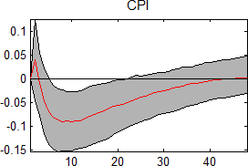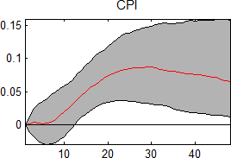

Note: As explained in the appendix of Haldane et at (2016), the impulse responses shown above are from a VAR model estimated on the series of actual JGB asset purchases by the Bank of Japan, identified with a Choleski decomposition. The left hand chart suggests that QE1 in Japan did not have an impact on prices, which is roughly in line with the survey in Ugai (2007). The multipliers in the second panel suggest, once the total size of purchases is taken in account, a similar total impact as found in Bank of Japan (2015).

# Liquidity Frictions

###### UK Market Liquidity Measure and Regime US Market Liquidity Measure and Regime

1.2

1.0

0.8

0.6

0.4

0.2

0.0

2006 2008 2010 2012 2014

0.20

0.18

Regime (LHS)

Government Bond

Market Illiquidity Measure (RHS)

0.16

0.14

0.12

0.10

0.08

0.06

0.04

0.02

0.00

1.2

1.0

Regime (LHS)

Government Bond

Market Illiquidity Measure (RHS)

0.8

0.6

0.4

0.2

0.0

2006 2008 2010 2012 2014

0.25

0.20

0.15

0.10

0.05

0.00

**State-dependence of QE**

**Peak impact of a central bank balance sheet expansion of 1% of nominal GDP**



|  |  |  |
| --- | --- | --- |
| **Country/Regime** | Real GDP | CPI |
| **US / High financial frictions regime** | 0.60 | 0.73 |
| **US / Low financial frictions regime** | 0.32 | 0.485 |
| **UK / High financial frictions regime** | 0.24 | 0.645 |
| **UK / Low financial frictions regime** | 0.14 | 0.48 |

Source: Bank calculations.

Asterisk indicates that the estimated impact is statistically significant.

Based on a structural vector autoregression (SVAR) model containing, as endogenous variables:

CPI (natural logarithm); real GDP (natural logarithm); yield on 10-year government bond; real equity prices (natural logarithm); size of the balance sheet divided by nominal GDP, scaled by the level of nominal GDP in the first period prior of the expansion. Regime dependence is factored into the contemporaneous covariance matrix and identified using an indicator of frictions in the government bond market.

Average of results of four different identification schemes is shown. The individual schemes are: zero restrictions; sign restrictions; a combination of zero and sign restrictions; sign variance decomposition restrictions.



**International spillovers from QE**

53

**Exchange rate channel**

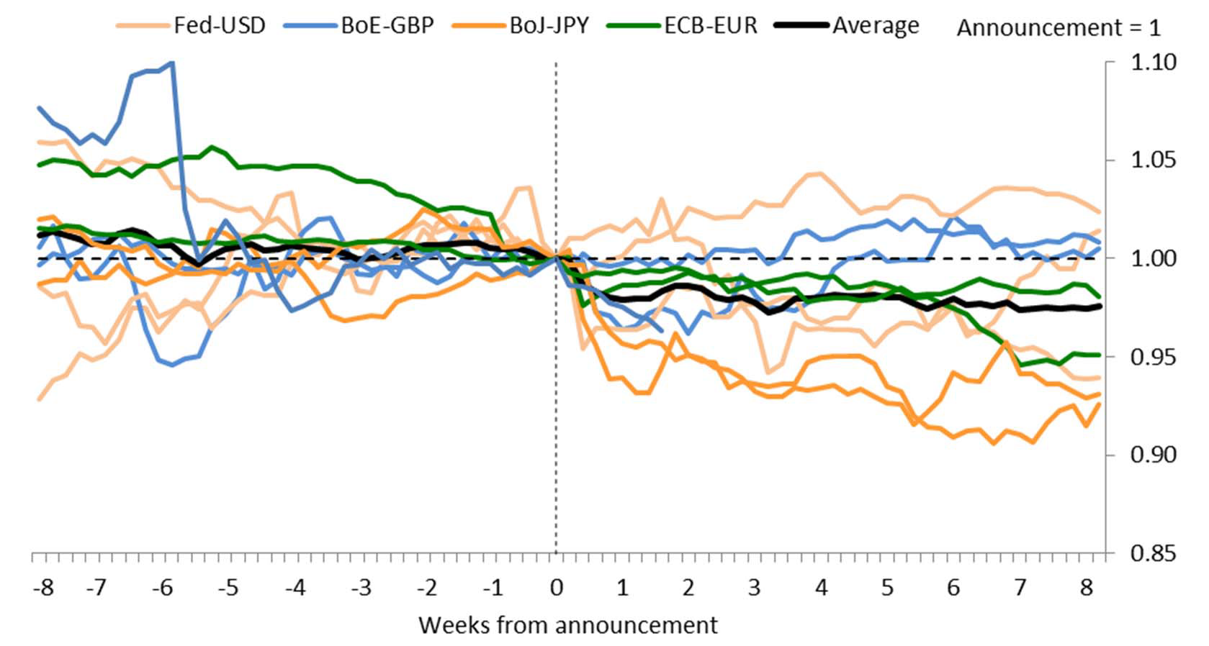**FX dynamics around selected QE announcements**

Sources: Bank of England, ECB, Federal Reserve, Bloomberg, Bank of Japan, Bank calculations.

**Evidence on spillovers to UK asset prices**

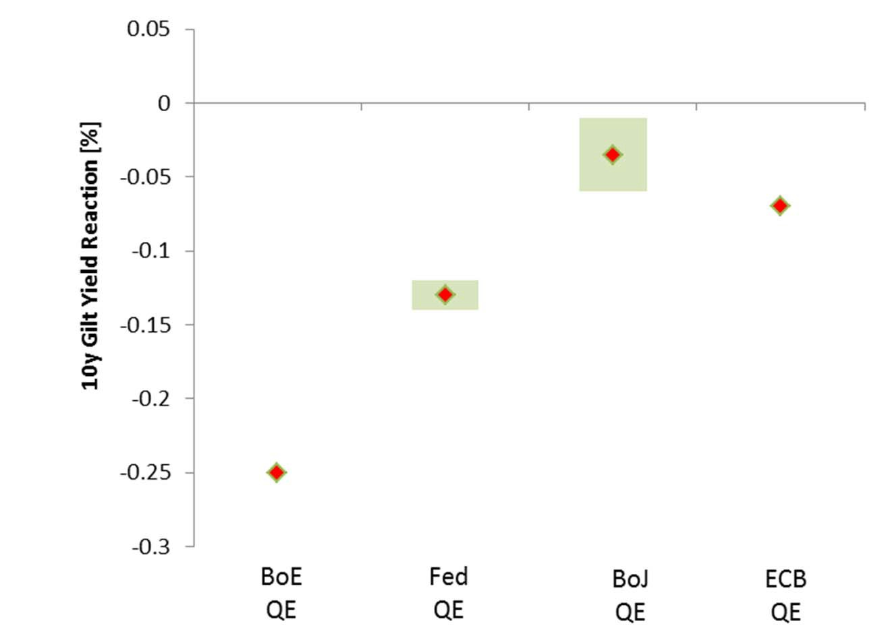

Source: Rogers et al. (2014); Bank calculations; ECB refers to PSPP extension

**Correlation of term premia estimates**

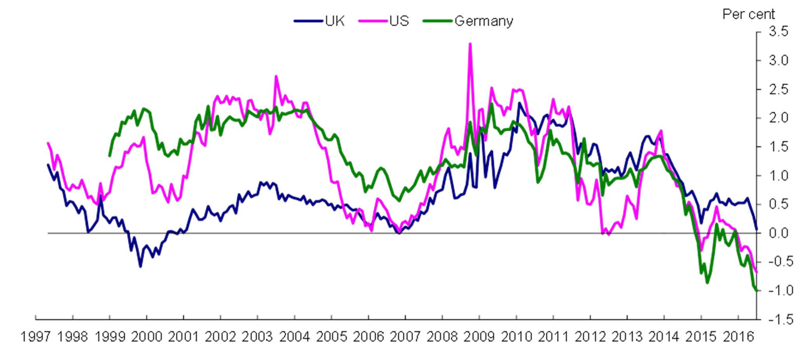**10 year spot nominal government bond term premia estimates**

Sources: Bloomberg, Bank calculations, New York Fed. Term premia estimates for the US from model by Adrian, Crump and Moench (2013), applied to the UK and Germany following Malik and Meldrum (2014).

**The Transmission of US QE**

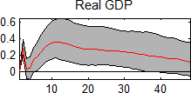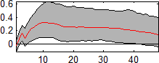US Response to US QE** UK Response to US QE**

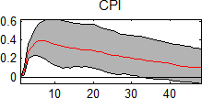

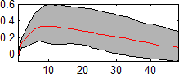

** 1% expansion of Fed balance sheet in terms of nominal GDP. See Haldane et al (2016)



**The International Transmission of US QE**

UK Response to UK QE1 UK Response to US QE2

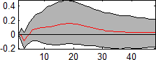

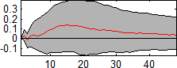1 1% expansion of BoE balance sheet in terms of nominal GDP 2 1% expansion of Fed balance sheet in terms of nominal GDP See Haldane et al (2016) See Haldane et al (2016)



**Conclusion**

* **Aggregate impact of QE:**
  + **reasonably well-defined**
  + **state-dependent**
  + **international**
* **Distributional impact of QE:**
  + **… for another day …**